READ ME

1. Open ‘grep.py’ using **python 32 bit** to view how the target sentences were retrieved from Brown Corpus.
2. Open ‘condition.py’ using **python 64 bit** to view the construction of lists and the interface. (Those two files were stored separately because NLTK module requires 32 bit while SimpleGuitk module requires 64 bit python program.)
3. **How to import SimpleGuitk module to PC:**

**Step 1**: Download simpleguitk 1.1.3 from <https://pypi.python.org/pypi/SimpleGUITk>. (The file has already be downloaded and unzipped. Please save the folder somewhere in your computer.)

**Step 2**: Go to control panel and select ‘system and security’ – ‘view basic information about your computer’.

**Step 3**: Go to ‘Advanced system settings’. Under ‘Advanced’ tags, scroll down in ‘System variables’ and select ‘Path’. Click on it and at the end of ‘Variable value’ input area, add ‘; C:\Python34’ (determined by where you stored the python and the version of python on your computer)

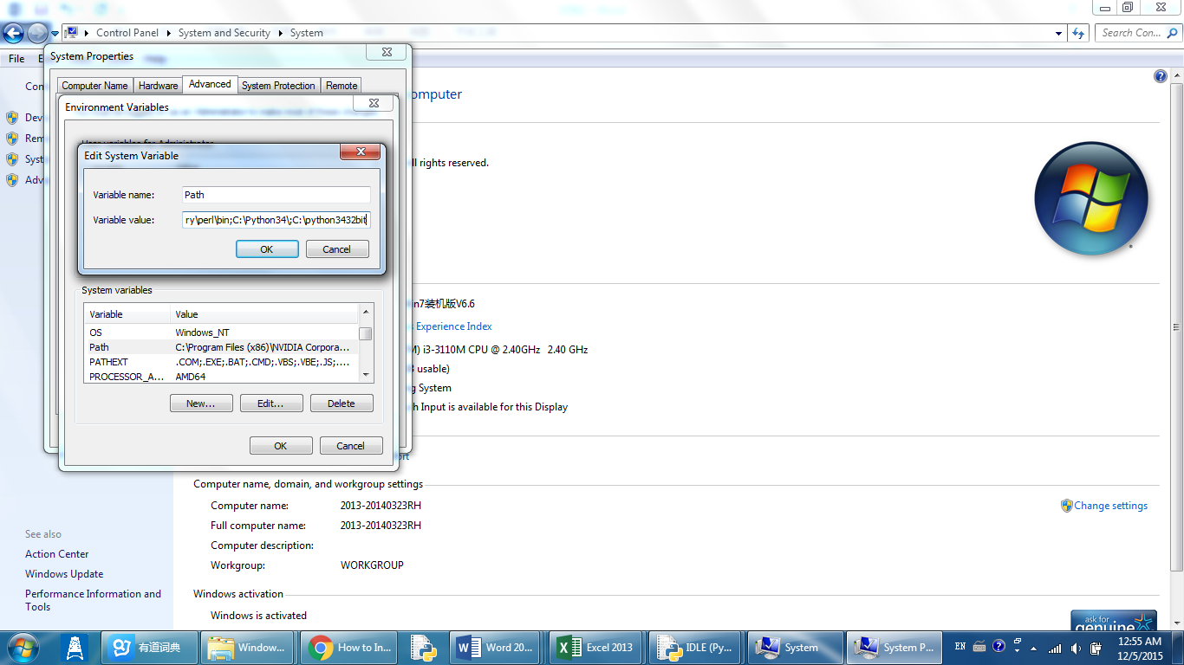

**Step 4**: Open the command prompt and type ‘python’ to ensure it has been added to the path.

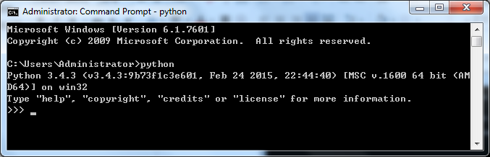

**Step 5**: Return to home directory (C:\Users\Administrator) and input ‘cd C:\Users\Administrator\Downloads\SimpleGUITk-1.1.3’ (determined by the full path of the folder where you stored the SimpleGuitk folder) and hit ‘enter’.

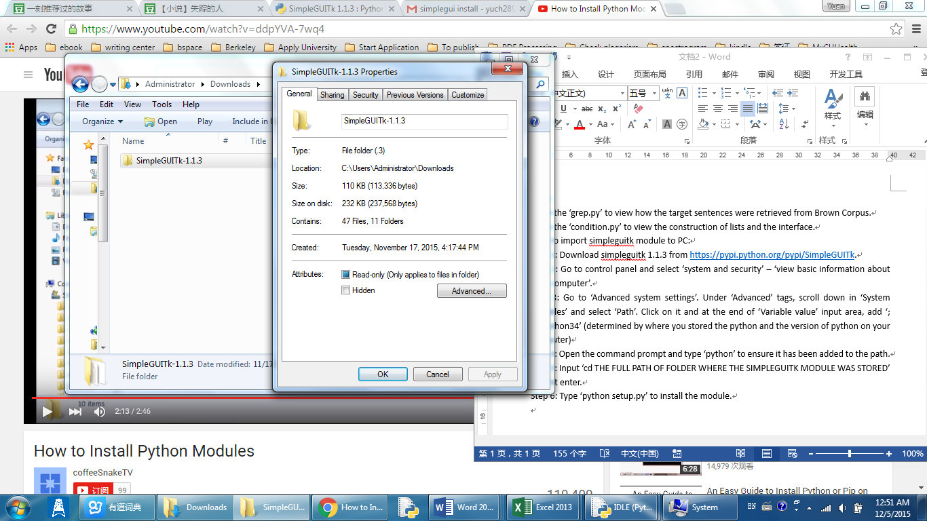

**Step 6**: Type ‘python setup.py’ to install the module.

**Step 7**: Type ‘simpleguitk’ to test whether it has been sucessfully installed.